Synopsis on
“ AI-Assisted Defect Detection for Smart Manufacturing Applications”
A synopsis to be submitted by

TARAKESHWAR REDDY PERAM | 500120133 | Mechanical
ASHWINI KUMAR | 500122508 | Mechanical
VIVEK MITTAL | 500119239 | Mechanical

In Partial Fulfillment of the Requirements for the Degree of
BACHELOR OF TECHNOLOGY

Supervisor
Dr. Ankit Nayak
Designation, Department
UPES, Dehradun, Uttarakhand
Co-Supervisor (If any)
Dr. xxxxxxxxx
Designation, Department
UPES, Dehradun, Uttarakhand


UPES
Mechanical Cluster
Dehradun – Uttarakhand 248007 (India)
SEPTEMBER 2026

UPES, Dehradun
INDIA

Certify that I have read this synopsis, and, in my opinion, it is fully adequate, in scope and quality, as a synopsis for the degree of Bachelor of Technology in Engineering.

Dr. Ankit Nayak
Supervisor


UPES

LETTER OF ACCEPTANCE

We hereby accept the synopsis entitled “AI-Assisted Defect Detection for Smart Manufacturing Applications”, prepared by “Tarakeshwar Reddy Peram, Ashwini Kumar, Vivek Mittal” under the supervision of Dr. Ankit Nayak, in partial fulfillment of the requirements for the award of the degree of Bachelor of Technology (B.Tech.) in Engineering.

Committee Members
Name Signature
1.
2.
3.

TABLE OF CONTENT

1 Introduction 1
2 Literature Survey 2
2.1 Research Gap 2
2.2 Challenges 3
3 Objectives 4
4 Methodology 3
4.1 Proposed Model (if any) 5
4.2 Experimental Setup/Numerical Methodology 6
5 Expected Outcomes 7
6 Time Activity Chart 8
7 References 9

Introduction

Manufacturing industries continuously focus on maintaining product quality while reducing inspection time, human error, and production losses. Quality inspection is an important part of the manufacturing process because even small defects can affect the performance, appearance, and reliability of a product. Traditional inspection methods commonly depend on manual observation, which can become difficult when products need to be inspected continuously and at high production rates.

The development of Artificial Intelligence (AI) and computer vision has created opportunities for automating visual inspection in manufacturing. AI-based systems can analyze product images and identify patterns that may indicate defects. Such systems can assist human inspectors by providing faster and more consistent inspection results.

This project proposes an AI-Assisted Defect Detection System for Smart Manufacturing Applications with a specific focus on detecting surface cracks and color defects. The proposed system will use image datasets during the initial simulation phase. An AI-based approach will be investigated for crack detection, while image-processing and color-analysis techniques will be used to identify unwanted color variations.

The project will be developed in two phases. Phase 1 will focus on simulation, including dataset preparation, defect detection, system integration, and performance evaluation. The objective of this phase is to establish a working software-based inspection system before introducing physical hardware.

Phase 2 will focus on hardware implementation and IoT integration. A camera and mini conveyor-based setup will be developed to simulate a manufacturing inspection line. An ESP32 will be used for communication and hardware control, while an IoT dashboard will provide real-time information about inspection results and system status.

The proposed system aims to demonstrate how AI, computer vision, embedded systems, and IoT can be combined to create a low-cost smart manufacturing inspection prototype.

Literature Survey
Automated visual inspection has become an important area of research in smart manufacturing. Traditional inspection systems generally depend on predefined image-processing rules, while recent approaches increasingly use machine learning and deep learning to identify complex defect patterns. [1], [2]
Computer vision techniques have been applied to various manufacturing inspection problems, including surface cracks, scratches, dents, stains, and other abnormalities. Deep learning models are particularly useful because they can learn visual characteristics directly from training images instead of relying entirely on manually designed features. [1], [2]
Object detection and image segmentation models can be used to locate defects within a product image. For crack inspection, segmentation can be particularly useful because cracks can be thin, irregular, and spread across different regions of a surface. A YOLO-based detection or segmentation approach can therefore be investigated for the proposed system. [3]
Color inspection is another important aspect of manufacturing quality control. Variations in illumination and surface reflection can make simple RGB-based comparison unreliable. Color spaces such as HSV and CIELAB provide alternative representations for analyzing color differences. In particular, CIELAB can be used with color-difference measurements to determine whether the observed product color differs significantly from a reference color. [4]
The development of Industry 4.0 has also encouraged the integration of inspection systems with connected devices. IoT-enabled systems can transmit inspection information to a central dashboard, allowing production quality and system status to be monitored in real time. [5]
Based on these developments, the proposed project combines AI-based crack detection, computer-vision-based color inspection, physical inspection hardware, and IoT monitoring within a single prototype.

Research Gap
Although considerable work has been carried out in automated defect detection, several opportunities remain for developing an integrated and low-cost inspection prototype.
Many existing systems concentrate on a particular defect type or a specific industrial application. Crack detection and color inspection are often developed as separate tasks. In addition, research implementations may focus primarily on model performance without demonstrating how the detection system can be connected to a physical manufacturing setup.
There is therefore a need for a relatively simple system that can demonstrate the complete process from visual inspection to defect decision and real-time monitoring. Such a system should also be practical to implement using affordable hardware.
The proposed project addresses this gap by combining crack detection and color defect detection during simulation and subsequently integrating the developed system with a camera, conveyor prototype, ESP32, and IoT dashboard.

Challenges
The major challenges expected during the development of the project include:
- Obtaining a suitable dataset containing both defective and non-defective product images.
- Preparing and annotating images for crack detection.
- Detecting small, thin, or irregular cracks accurately.
- Distinguishing actual color defects from changes caused by lighting and reflections.
- Selecting suitable thresholds for color-difference analysis.
- Reducing false detections during image analysis.
- Maintaining consistent camera positioning and illumination in the hardware setup.
- Integrating the AI system with the ESP32 and physical inspection components.
- Establishing reliable communication between the hardware and IoT dashboard.
- Maintaining consistent detection performance when moving from simulation to real-world samples.

Objectives
Phase 1: Simulation and AI-Based Defect Detection
- To develop an AI-assisted computer vision system for detecting surface cracks in manufactured products using suitable image datasets.
- To develop a color-based defect detection method for identifying deviations from the desired product color.
- To integrate the crack and color detection methods to classify products as defective or non-defective in a simulated manufacturing environment.
Phase 2: Hardware Implementation and IoT Integration
- To implement the developed defect detection system on a physical prototype using a camera and mini conveyor-based setup.
- To integrate the inspection system with an ESP32-based hardware setup for real-time product detection and PASS/FAIL indication.
- To develop an IoT-based monitoring dashboard for displaying real-time inspection results and manufacturing defect statistics.

Methodology
The project will be carried out in two phases so that the software-based inspection system is established before its integration with physical hardware.

Phase 1 — Simulation

The first phase will begin with the collection and preparation of suitable datasets for crack and color defect detection. Images will be preprocessed to improve their suitability for analysis. Crack images will be used to train and evaluate an appropriate AI-based detection model.
For color inspection, the images will be analyzed using suitable color-space techniques. A reference color will be established for the selected product, and the observed product color will be compared against this reference.
The outputs from both inspection methods will then be combined to generate a final product-quality decision.

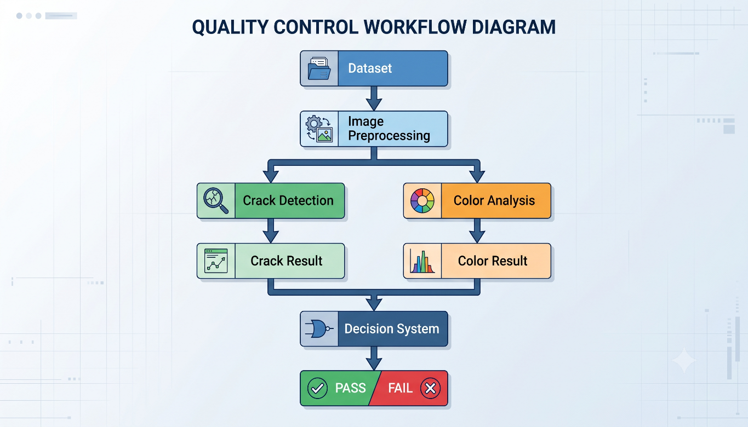

Phase 2 — Hardware Implementation

After completing the simulation, the developed system will be integrated into a small physical manufacturing prototype. A mini conveyor will be used to move sample products through an inspection area. A camera positioned above the conveyor will capture the products.
The captured images will be processed by the AI and computer-vision system. The inspection result will then be communicated to an ESP32. LEDs and a buzzer can provide immediate PASS/FAIL feedback, while an optional servo mechanism can be used to demonstrate automatic rejection of defective products.
The ESP32 will also communicate the relevant inspection information through Wi-Fi to an IoT dashboard.

Proposed Model (if any)
The proposed system will follow a hybrid defect-detection approach, where AI is primarily used for crack detection and image-processing techniques are used for color inspection.
Crack Detection
A suitable YOLO-based detection or segmentation model will be trained using annotated crack images. The model will identify whether a crack is present and provide its location within the product image.
The crack detection output may include:
- Crack presence
- Crack location
- Detection confidence
- Number of detected cracks
- Approximate defect severity

Color Defect Detection
Color inspection will use a suitable color representation, with CIELAB being considered for color comparison. The actual product color will be compared with the predefined acceptable reference color.
The system will determine whether the difference falls within the acceptable range and classify the product accordingly.
Final Decision
The two inspection results will be combined through a decision stage:
Crack Detected? ─────┐
Decision → PASS / FAIL
Color Defect? ──────┘

A product will be considered defective if it exceeds the defined criteria for either crack detection or color variation.

Experimental Setup
Phase 1 — Simulation Setup
The simulation phase will be performed using a computer system and will consist of:
- Crack image dataset
- Color defect/reference images
- Image preprocessing
- AI-based crack detection model
- Color analysis algorithm
- Defect classification logic
- Performance evaluation
- Inspection-results dashboard

The system will provide outputs such as:

Product ID: P001
Crack: Detected
Confidence: 96%
Color Defect: No
Final Result: FAIL

For a normal product:
Product ID: P002
Crack: Not Detected
Color Defect: No
Final Result: PASS

Phase 2 — Hardware Setup
The hardware prototype will consist of:
Component | Purpose
Mini conveyor | Movement of sample products
Camera | Product image acquisition
Laptop/PC | AI and image processing
ESP32 | Hardware control and Wi-Fi communication
IR sensor | Product detection
DC motor | Conveyor movement
Motor driver | Motor control
LED indicators | PASS/FAIL indication
Buzzer | Defect alert
Servo motor (optional) | Physical rejection demonstration
IoT dashboard | Real-time monitoring
The AI processing can initially be performed on a laptop/PC, while the ESP32 manages the sensors, indicators, and communication. This approach reduces the hardware cost and simplifies the prototype.

Expected Outcomes
The expected outcomes will directly correspond to the objectives of both phases.
Phase 1 — Simulation
- A functional AI-assisted computer vision system capable of detecting surface cracks in manufactured products from image datasets.
- A functional color-based defect detection system capable of identifying deviations from the desired product color.
- An integrated simulation system capable of combining crack and color detection and classifying products as defective or non-defective.
Phase 2 — Hardware and IoT
- A physical prototype integrating the developed defect detection system with a camera and mini conveyor-based inspection setup.
- An ESP32-based hardware system capable of receiving inspection results and providing real-time PASS/FAIL indications.
- An IoT-based monitoring dashboard capable of displaying real-time inspection results and manufacturing defect statistics.

Time Activity Chart
Activity | Sep | Oct | Nov | Dec | Jan | Feb | Mar | Apr | May
Literature Survey & Problem Definition | ✓ | ✓
Dataset Collection | ✓ | ✓
Data Preprocessing & Annotation |  | ✓ | ✓
Crack Detection Model |  |  | ✓ | ✓
Color Defect Detection |  |  | ✓ | ✓
AI Model Integration |  |  |  | ✓
Simulation Testing & Evaluation |  |  |  | ✓
Phase 1 Completion |  |  |  | ✓
Hardware Selection & Procurement |  |  |  |  | ✓
Conveyor & Camera Setup |  |  |  |  | ✓ | ✓
ESP32 & Sensor Integration |  |  |  |  |  | ✓
AI-Hardware Integration |  |  |  |  |  | ✓ | ✓
IoT Dashboard Development |  |  |  |  |  |  | ✓ | ✓
Complete System Integration |  |  |  |  |  |  |  | ✓
Testing & Validation |  |  |  |  |  |  | ✓ | ✓
Final Documentation & Demonstration |  |  |  |  |  |  |  |  | ✓

References

[1] N. Hütten, M. Alves Gomes, F. Hölken, K. Andricevic, R. Meyes, and T. Meisen, “Deep Learning for Automated Visual Inspection in Manufacturing and Maintenance: A Survey of Open-Access Papers,” Applied System Innovation, vol. 7, no. 1, Art. no. 11, 2024, doi: 10.3390/asi7010011.
[2] X. Zheng, S. Zheng, Y. Kong, and J. Chen, “Recent advances in surface defect inspection of industrial products using deep learning techniques,” The International Journal of Advanced Manufacturing Technology, vol. 113, pp. 35–58, 2021, doi: 10.1007/s00170-021-06592-8.
[3] A. Bochkovskiy, C.-Y. Wang, and H.-Y. M. Liao, “YOLOv4: Optimal Speed and Accuracy of Object Detection,” arXiv preprint arXiv:2004.10934, 2020.
[4] M. R. Luo, G. Cui, and B. Rigg, “The development of the CIE 2000 colour-difference formula: CIEDE2000,” Color Research & Application, vol. 26, no. 5, pp. 340–350, 2001, doi: 10.1002/col.1049.
[5] L. S. Dalenogare, G. B. Benitez, N. F. Ayala, and A. G. Frank, “The applications of Industry 4.0 technologies in manufacturing context: a systematic literature review,” International Journal of Production Research, vol. 59, no. 6, pp. 1922–1954, 2021, doi: 10.1080/00207543.2020.1824085.

